Leaving Cert Physics Worked Solutions 2013

2013 Question 1
- How did the student find the centre of gravity of the metre stick?
Balanced (horizontally) at a point (fulcrum) / suspended (horizontally) from a string
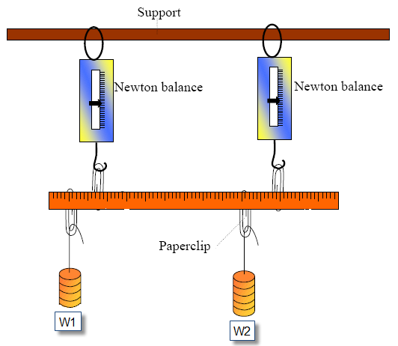
- The centre of gravity was at the 50.3 cm mark rather than the mid-point of the metre stick. Explain.
Metre stick not uniform / stick chipped / extra material on one end
- How did the student ensure that the system was at equilibrium?
The system was not moving
- Draw a diagram of the experimental arrangement that the student used.
Similar to diagram (metre stick horizontal and suspended from two spring balances) but with three weights suspended from stick
- calculate the total of the clockwise moments
Moment = force ×distance (= F × d)
(5.7 × 0.197) + (1.3 × 0.003) + (4.0 × 0.3) = 1.1229 + 0.0039 + 1.2 = 2.3268 N m
- calculate the total of the anti-clockwise moments
(2.0 × 0.386) + (3.0 × 0.282) + (4.6 × 0.154) = 0.772 + 0.846 + 0.7084 = 2.3264 N m
- Explain how these results verify the laws of equilibrium
Forces up = forces down (= 10.3 N)
total clockwise moments ≈ total anticlockwise moments

2013 Question 2

- What physical quantities do X and Y represent?
Pressure and volume (or height)

- Name the units used when measuring these quantities.
N m^{–2} kPa, Pa, // cm³ (m³, mm³, cm, etc.)

- Draw a labelled diagram of the apparatus that the student used in the experiment.
The diagram must include the following:
gas labelled in container with graduations, labelled pressure gauge, labelled means of adjusting pressure or volume

- Describe the procedure he used to obtain these readings.
Method used to noting pressure and volume readings
Method of changing pressure or volume (e.g. piston)
Note (new) pressure and volume reading

- Use the data in the table to draw an appropriate graph on graph paper.

X | 120 | 160 | 200 | 240 | 280 | 320
1/X | 0.0083 | 0.00625 | 0.005 | 0.0042 | 0.0036 | 0.0031
Y | 52 | 39.1 | 31.1 | 25.9 | 22.2 | 19.6
1/Y | 0.019 | 0.026 | 0.032 | 0.039 | 0.045 | 0.051

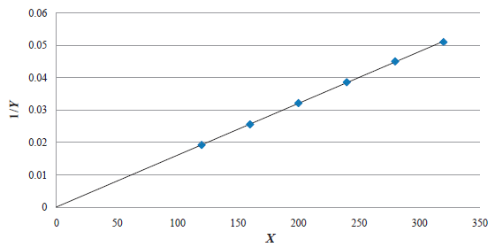

- Explain how your graph verifies Boyle’s law.
A straight line through the origin implies pressure is inversely proportional to volume

2013 Question 3

- Draw a labelled diagram of the apparatus used.
Apparatus: e.g. bulb, mirror, screen 3 (components appropriately consistent and each labelled) correct arrangement and correct shape of mirror

- Give two precautions that should be taken when measuring the image distance.
Measure from the back of the mirror / measure from the centre (pole) of the mirror / avoid parallax error / ensure image is sharp / have both screen and mirror vertical, etc.

- Explain why the student was unable to form an image on the screen when the object was close to the mirror.
The object was inside the focal length / virtual image formed

- Use all of the data in the table to calculate a value for the focal length of the mirror.
u/cm | 24.0 | 32.0 | 40.0 | 48.0
 | 0.042 | 0.031 | 0.025 | 0.021
v/cm | 72.5 | 40.3 | 33.0 | 27.9
 | 0.014 | 0.025 | 0.030 | 0.036

f ≈ 17.9 cm

- Describe how the student could have found an approximate value for the focal length of the mirror before starting the experiment.
Focus the image of a distant object onto a screen.
Measure the distance from the mirror to the screen.

2013 Question 4

V/V | 1.0 | 2.0 | 3.0 | 4.0 | 5.0 | 6.0
I/A | 0.17 | 0.34 | 0.50 | 0.64 | 0.77 | 0.88
- Draw and label the circuit diagram used by the student.
apparatus: p.s.u. / battery, ammeter, voltmeter
ammeter in series with conductor
voltmeter in parallel with conductor

- Name the device in the circuit that is used to vary the potential difference across the conductor.
Variable p.s.u. / variable resistor (rheostat) / potential divider

- Explain how the student used this device to vary the potential difference.
Rotated the dial, moved the sliding contact

- Use the data in the table to draw a graph on graph paper to show the variation of current with potential difference.

- Use your graph to find the value of the resistance of the conductor when the current is 0.7 A.
V ≈ 4.5 V (when I = 0.7 A on graph)
R ≈ 6.4 Ω

- Explain the shape of your graph.
Resistance (of conductor) increases with increasing temperature
Or appropriate reference to Ohm‟s law and to resistance

2013 Question 5
What is the shortest stopping time for a car which is travelling at 16 m s⁻¹ and has a maximum deceleration of 2.5 m s⁻²? | v = u + at. 0 = 16 – 2.5t  t = 6.4 secs
State the law of conservation of momentum. | The principle of conservation of momentum states that in any collision between two objects, the total momentum before impact equals total momentum after impact, provided no external forces act on the system.
Explain why heat does not travel through solids by means of convection. | The particles cannot move freely
Storage heaters are frequently used to heat buildings. State the principle that underlies the operation of an electrical storage heater. | Storage heaters are heated when electricity is inexpensive (off peak). They have a large heat capacity which means that they can absorb a of heat energy with only a small increase in temperature. This means that they release the heat slowly the following day.
If a diamond has a refractive index of 2.42, what is the speed of light in the diamond? | $2.42= \frac{speed of light in air}{speed of light in diamond}$ $speed of light in diamond= \frac{3{ × 10}^{8}}{2.42}$  Speed of light in diamond = 1.24 × 10⁸ m s⁻¹
Define the volt | The potential difference between two points is one volt if 1 joule of work is needed to move 1 coulomb of charge from one point to the other
A positively-charged rod is brought near to a neutral, conducting sphere that is on top of an insulating stand, as shown in the diagram. How would a student charge the sphere negatively by induction? | Earth the sphere  remove the earth connection and then  remove the rod.
Explain what is meant by the statement: “Zinc has a threshold frequency of 1.04 × 10¹⁵ Hz”. | Below this frequency electromagnetic radiation /photons will not cause emission of electrons from the surface of the zinc because the photons have insufficient energy.
Give one benefit of switching from fossil fuels to nuclear power for the generation of electricity.  Explain your answer. | No carbon dioxide is produced in nuclear power generation
Give an expression for the minimum frequency of a photon that can form an electron and a positron by pair production. | $$hf= m_{electron}c^{2}+m_{positron}c^{2}$$  but an electron and a positron have the same mass.  hf = 2mc² $f= \frac{2mc^{2}}{h}$
2013 Question 6

- State Newton’s law of universal gravitation.
Newton’s Law of Gravitation states that any two point masses in the universe attract each other with a force that is directly proportional to the product of their masses, and inversely proportional to the square of the distance between them.

- Explain what is meant by angular velocity.
Angular Velocity is the rate of change of angle with respect to time.

- Derive an equation for the angular velocity of an object in terms of its linear velocity when the object moves in a circle.
The definition of an angle (in radians) is: $θ= \frac{s}{r}$
Now divide both sides by t to get: $\frac{θ}{t}= \frac{s}{tr}$

But ω = $\frac{}{t}$ and v = $\frac{s}{t}$ so we get `$= \frac{v}{r}$

- Calculate (a) the angular velocity, (b) the linear velocity, of the ISS.
It takes the ISS 92 minutes 50 seconds to do one complete orbit.
This corresponds to the periodic time T, but we need to convert it into seconds.
T = 92 minutes 50 seconds = 5570 seconds
$ω= \frac{2π}{T}= \frac{2π}{5570}$ = 1.1 × 10⁻³ rad s⁻¹
v = rω
r in this context corresponds to the distance between the ISS and the centre of the Earth
r = radius of the Earth plus height of the ISS above the surface of the Earth.
r = (6.37 × 10⁶) + (4.13 × 10⁵) = 6.783 × 10⁶
v = rω
v = (6.783 × 10⁶)(1.1 × 10⁻³) = 7651.5 m s⁻¹

- Name the type of acceleration that the ISS experiences as it travels in a circular orbit around the earth.
Centripetal
What force provides this acceleration?
Gravitational force (note that you can’t use the word ‘gravity’)

- Calculate the attractive force between the earth and the ISS.
{We don’t have enough information to use Newton’s gravitational law formula, but we can use the fact the ISS is travelling in a circular orbit, and so use the equation for centripetal force; $F_{c}=\frac{mv^{2}}{r}$

‘m’ in this context corresponds to the mass of the orbiting body, and we were told in the question that the mass of the ISS is is 4.5 × 10⁵ kg}

$F_{c}=\frac{({4.5×10}^{5})({7651.5)}^{2}}{{6.783 × 10}^{6}}$ F = 3.884 × 10⁶ N
- Hence or otherwise, calculate the mass of the earth.
Centripetal force = gravitational force
$= \frac{GM_{1}M_{2}}{d^{2}}$
Now cancel one m and one d on both sides (both d and r represent the same distance in this context)
$v^{2}=\frac{GM}{r}$ $M=\frac{rv^{2}}{G}$ $M=\frac{(6.783 × {10}^{6})({7651.5)}^{2}}{6.7×{10}^{-11}}$ M = 5.95 × 10²⁴ kg
(other methods also acceptable – can you think of two others?)

- Why do occupants of the ISS experience apparent weightlessness?
They are in freefall // ISS accelerating at the same rate as occupants

- What is the period of a geostationary communications satellite?
One day

2013 Question 7

- What is meant by the term resonance?
Transfer of energy between two bodies with the same (or similar) natural frequency
OR Resonance is the transfer of energy so that a body vibrates at its natural frequency.

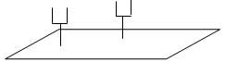
- How would resonance be demonstrated in the laboratory?
- Use two identical tuning forks (they must have the same frequency) and a sound-board.
- Start one fork vibrating and place it on the sound-board.
- Place the second tuning fork on the sound-board and then stop the first tuning fork from vibrating.
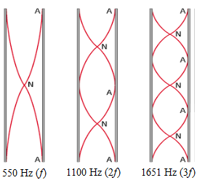
- The second fork can now be heard.

- What name is given to this set of frequencies?
Harmonics or overtones

- Draw labelled diagrams to show how the tube produces each of these frequencies.
See diagram

- Use any of the above frequencies to calculate a value for the speed of sound in air.
The length of the metal tube is 30 cm = 0.3 m
The distance between two consecutive antinodes is $\frac{}{2}$
$0.3=\frac{}{2}$ λ = 0.60 m c = fλ c = (550)(0.60) = 330 m s⁻¹

- Calculate the tension in the wire.
l = 64 cm = 0.64 m f = 173 Hz
We need to use the formula
{So before we do that we also need to calculate µ which represents the mass per unit length.
To work this out we divide a sample length of the wire by its corresponding mass.
“A sample of wire, of length 12 m and mass 48 g . . .”}

$µ=\frac{mass}{length}= \frac{0.048 }{12}$ $µ$ = 0.004 kg m⁻¹

4l²f² = $\frac{T}{µ}$ $µ$ 4l²f² = T

T = (0.004)(4)(0.64)²(173)² T = 196 N

2013 Question 8 (a)
(a)
- Name the parts labelled F, G and H.
F: transformer / iron core
G: diode
H: capacitor

- Describe the function of G in this circuit.
It acts as a rectifier: it converts a.c. to d.c.

- Sketch graphs to show how voltage varies with time for the input voltage and the output voltage

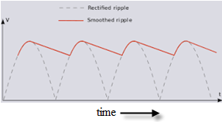
Input voltage Output voltage
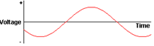

- Use the data printed on the device to calculate the maximum energy that it can store.
E = ½CV²
E = (½)(2200 × 10⁻⁶)(16)²
E = 0.2816 J

(b)
- Explain why high voltage is used.
High voltage uses low current minimising heat loss

- Calculate the resistance of the aluminium wire.
$ρ= \frac{RA}{l}$ $R= \frac{ρl}{A}$
Diameter = 18 mm r = 9 × 10⁻³ m
$A= πr^{2}=π$(9 × 10⁻³)²
$ρ=$resistivity of aluminium = 2.8 × 10⁻⁸ Ω m
l = 3000 m
$$R= \frac{(2.8 × {10}^{-8})(3000)}{π(9 × {10}^{-3})^{2}}$$
$R=0.33$ Ω

- Calculate how much electrical energy is converted to heat energy in the wire in ten minutes.
W = I²Rt
W = (250)²(0.33)(600) = 1.238 × 10⁷ J

2013 Question 8 (b)

- Explain why high voltage is used.
High voltage uses low current minimising heat loss

- Calculate the resistance of the aluminium wire.
$ρ= \frac{RA}{l}$ $R= \frac{ρl}{A}$
Diameter = 18 mm r = 9 × 10⁻³ m
$A= πr^{2}=π$(9 × 10⁻³)²
$ρ=$resistivity of aluminium = 2.8 × 10⁻⁸ Ω m
l = 3000 m
$$R= \frac{(2.8 × {10}^{-8})(3000)}{π(9 × {10}^{-3})^{2}}$$
$R=0.33$ Ω

- Calculate how much electrical energy is converted to heat energy in the wire in ten minutes.
W = I²Rt
W = (250)²(0.33)(600) = 1.238 × 10⁷ J

2013 Question 9
- Define the becquerel.
One Bq = one disintegration per second.

- Name one device used to detect ionising radiations.
GM tube / solid state detector etc.

- Compare alpha, beta, and gamma emissions using the following headings:
(a) penetrating ability, (b) deflection in a magnetic field.
Penetrating ability:
Gamma (most penetrating) > beta > alpha (least penetrating)
Deflection in a magnetic field:
Alpha, beta deflected, gamma not deflected. Alpha and beta deflected in opposite directions
- Explain what happens during nuclear fission.
A large nucleus splits into two smaller nuclei with the emission of energy and neutrons
- Write an equation for the beta-decay of iodine–131.
$${}_{53}^{131}I→{}_{54}^{131}{Xe+ {}_{-1}^{0}e}$$
- Estimate the fraction of the iodine–131 that remained after 40 days.
40 days = 5 half lives.
Fraction remaining = ½ × ½ × ½ × ½ × ½ = $\frac{1}{32}$

- Calculate the decay constant of caesium–137.
$T_{\frac{1}{2}}= \frac{\ln{2}}{λ}$ $λ= \frac{\ln{2}}{T_{\frac{1}{2}}}$

$T_{1/2}$ = (30)(365)(24)(60)(60) = 9.46 × 10⁸ seconds

$λ= \frac{\ln{2}}{T_{\frac{1}{2}}}$ $λ= \frac{\ln{2}}{9.46×{10}^{8}}$ $= 7.32 × {10}^{-10} s^{-1}$
- Hence calculate the number of caesium–137 atoms present in the sample.
A = λN

$N= \frac{A}{ λ}$ = $\frac{5000}{7.32 × {10}^{-10}}$ N = 6.83 × 10¹² atoms

2013 Question 10 (a)

- How did Cockroft and Walton accelerate the protons?
High voltage / large electric field
- How did they detect the alpha-particles?
When the alpha particles hit a zinc sulfide screen it resulted in flashes of light
- Write the nuclear equation for the reaction that occurred.
+ → + K.E.
- Indicate the historical significance of their observation.
It was the 1st experimental verification of E = mc² / first artificial splitting of the nucleus (atom) /
first transmutation using artificially accelerated particles
- Calculate the speed of a proton that has a kinetic energy of 700 keV.
The kinetic energy is 700 keV, so we need to convert this to Joules.
1eV =1.6 x 10^{–19} Joules
700 keV = (700 x 10³)(1.6 x 10^{–19}) Joules

Kinetic energy = 1.12 × 10^{–13} J

Now we use E_{kinetic} = ½mv²
1.12 × 10^{–13} = ½ mv²
$$v^{2}{=(2)(\frac{{1.12 × 10}^{–13}}{m} )}^{}$$

Mass of proton = 1.6730 × 10⁻²⁷ kg

$$v^{2}{=(2)(\frac{{1.12 × 10}^{–13}}{{1.6730 × 10}^{–27 }} )}^{}$$
v = 1.16 × 10⁷ m s⁻¹

- Why is the tube evacuated?
So that particles do not collide with gas particles

- What is the purpose of accelerating the particles to high velocities?
To overcome repulsive forces // to create new matter

- What is the purpose of the magnets?
To contain the particles (in a circular path)

- Give an advantage of a circular accelerator over a linear accelerator.
Takes up less space // particles can achieve greater energy / speed

Can an accelerator of this design be used to accelerate neutrons? Explain your answer.
No
Neutrons have no charge and are therefore not affected by electric / magnetic fields

2013 Question 11

  - Seismic waves can be longitudinal or transverse. What is the main difference between them?
A longitudinal wave is a wave where the direction of vibration is parallel to the direction in which the wave travels.
A transverse wave is a wave where the direction of vibration is perpendicular to the direction in which the wave travels.

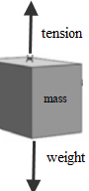
  - How far is the station from the centre of the earthquake?
speed = distance/time distance = (speed)(time) = (5000)(27) = 135000 m
  - Draw a diagram to show the forces acting on the suspended mass when the seismometer is at rest.
Weight acting downwards and tension acting upwards

  - What is the value, in kilograms, of the suspended mass?
Weight = mg
49 = m(9.8)
m = 5 kg
  - What type of motion does the frame have when it moves relative to the mass?
Simple harmonic motion

  - Give an equation for the acceleration of the ground in terms of the periodic time of the wave motion and the displacement of the ground.
The general equation for shm is a = ω² s
We need to introduce an expression for periodic time (T) into this somehow.
We know that the relationship between T and ω is: T = $\frac{2π}{ω}$ so $ω$ = $\frac{2π}{T}$
$ω^{2}$ = $\frac{4π^{2}}{T^{2}}$
We can now substitute this expression for $ω^{2}$ into a = ω² s
$a=\frac{4π^{2}}{T^{2}}$s

  - If the period of the ground motion was recorded as 17 seconds and its amplitude was recorded as 0.8 cm, calculate the maximum ground acceleration at the recording station.
In the equation for simple harmonic motion a = ω² s, s represents displacement.

Amplitude represents maximum displacement, so 0.8 cm (0.0008 m) represents s_{max}

a = ω² s a_{max} = ω² s_{max}
$$a_{max}=\frac{4π^{2}}{{17}^{2}}(0.008)$$
a_{max} = 0.0011 m s⁻²

  - Explain why an emf is generated in the coil.
The magnetic flux passing through the coil is changing

2013 Question 12 (a)
- State the law of conservation of energy.
The principle of conservation of energy states that energy cannot be created or destroyed but can only be converted from one form to another.

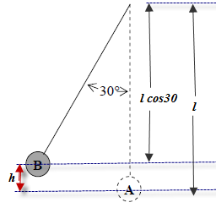
- Calculate the height through which the bob has been raised and the potential energy that it has gained.
From the diagram you should be able to work out that h = (1 – l cos θ)
h = 8 – 8 cos 30 = 1.07 m
E = mgh = (6)(9.8)(1.07) = 63 J

- What is the maximum velocity it attains?
Kinetic energy at the bottom = potential energy at the top
½mv² = mgh
(½)(6)(v²) = 63 J
v = 4.58 m s⁻¹

- Calculate the force applied.
W = Force×distance

$F=\frac{W}{d}=\frac{63}{.005}$ = 12604.3 N

2013 Question 12 (c) [Higher Level]  Calculate the force of repulsion between two small spheres when they are held 8 cm apart in a vacuum (each sphere has a positive charge of +3 μC).  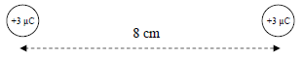 | d = 8 cm = 0.08 m  Q₁ = Q₂ = 3 × 10⁻⁶ C  F =  F = $\frac{1}{(4)(π{)(8.9×10}^{-12})}\frac{{(3×10}^{-6})({3×10}^{-6})}{0{.08}^{2}}$  F = 12.64 N

2013 Question 12 (b)
- What is meant by dispersion?
Dispersion is the separating out of the different colours present in white light.
- Give two differences between . . .
Red light deviated least in a prism and deviated the most in a grating
Many spectra observable with a grating, only one with a prism
- Give another example of light undergoing dispersion.
A rainbow
- What causes the sodium atoms to emit this light?
Electrons changing energy levels
Calculate the highest order image that could be produced when a beam of light of this wavelength is incident perpendicularly on a diffraction grating that has 300 lines per mm.
{Here we will use the formula nλ = d Sin θ
The maximum that θ could be is 90⁰, so Sin θ = 1 so the formula becomes nλ = d, $n=\frac{d}{}$}
$d=\frac{1}{300000}$ = 3.33 ×10⁻⁶ m n = $\frac{{3.33 ×10}^{-6}}{{589×10}^{-9}}$ = 5.65
The highest order image is 5
2013 Question 12 (c)
- Define the unit of charge, the coulomb.
The coulomb is the amount of charge that passes when one amp flows for one second.
- State Coulomb’s law
Coulomb’s Law states that the force between two point charges is proportional to the product of the charges and inversely proportional to the square of the distance between them.
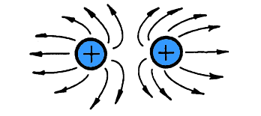
- Calculate the force of repulsion between two small spheres when they are held 8 cm apart in a vacuum.
F = F = $\frac{1}{(4)(π{)(8.9×10}^{-12})}\frac{{(3×10}^{-6})({3×10}^{-6})}{0{.08}^{2}}$ F = 12.64 N
- Copy the diagram above and show on it the electric field generated by the charges.
See diagram – curved deviation of the field lines needs to be clearly evident

- Mark on your diagram a place where the electric field strength is zero.
Neutral/null point marked halfway between charges

2013 Question 12 (d)
- What is meant by the term thermometric property?
A property that changes measurably with temperature.

- What is the temperature of the water when the resistance of the thermistor is 420 kΩ?
.Read directly from the graph to get approximately 37⁰ C

- What is the temperature of the water in the tank as measured by the thermocouple thermometer?
As the temperature goes from ⁰C to 100 ⁰C, the emf goes from 0 V to 815 μV
So an increase of 1μV corresponds to a temperature difference of $\frac{100}{815}$ or 0.1227 ⁰C (assuming linearity)
319 μV therefore corresponds to a temperature of $\frac{100}{815}$ × 319 = 39.14 ⁰C

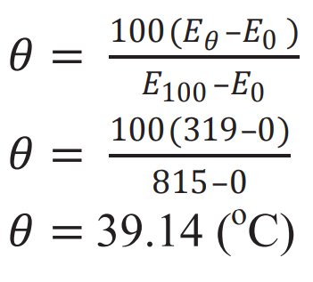
This is all very odd. The whole reason we talk about a calibration ‘curve’ is because we can’t assume linearity yet (within the confines of this syllabus) we can’t do this question without assuming linearity.
The alternative approach (see screengrab) is taken directly from the marking scheme but there is nothing on the syllabus to indicate that you are expected to know this).

- Why do the thermistor and the thermocouple thermometer give different temperature readings for the water in the tank?
Each of the thermometers has a different thermometric property which changes differently with temperature

